**Ideation Phase**

**Define the Problem Statements**

|  |  |
| --- | --- |
| Date | 26 June 2025 |
| Team ID | LTVIP2025TMID54605 |
| Project Name | shopEZ |
| Maximum Marks | 2 Marks |

**Customer Problem Statement Template:**

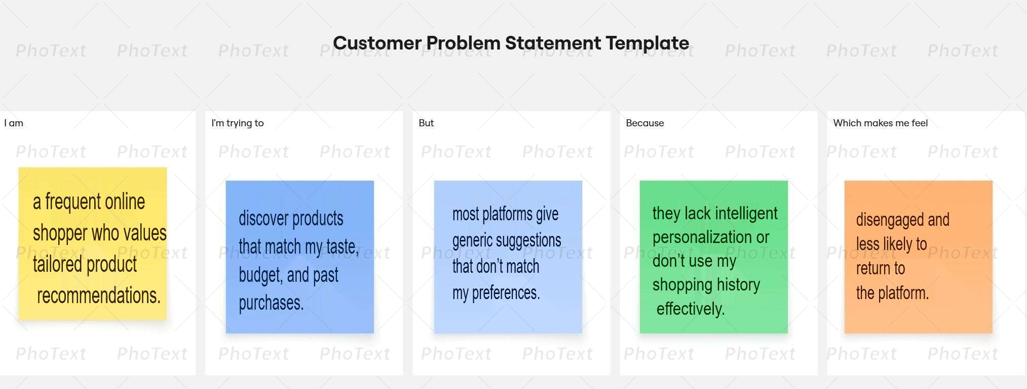To define the core problems users and sellers face in the online shopping ecosystem, and use those insights to guide the development of **ShopEZ.**

|  |  |  |  |  |  |
| --- | --- | --- | --- | --- | --- |
| **Problem Statement (PS)** | **I am (Customer)** | **I’m trying to** | **But** | **Because** | **Which makes me feel** |
| PS-1 | a regular online shopper looking for convenient and personalized experiences. | find the right products quickly and get through checkout seamlessly. | many platforms are cluttered, lack clear reviews or discounts, and have complicated checkout processes. | they aren’t optimized for discovery or personalized interactions. | frustrated and hesitant to complete my purchase. |
| PS-2 | an independent seller trying to grow my business online. | manage orders efficiently and understand what products are performing best. | existing platforms don’t give clear analytics or easy management tools. | they’re often built for large enterprises, not individual sellers. | overwhelmed and disconnected from my customers. |